Groundwater hydrology

SHEET (1)

(1) For the following data: Volume of voids in the soil sample (V_{v}) = 0.25 m³, total volume the soil sample (V_{t}) = 0.9 m³, compute Porosity (n).
(2) An undisturbed sample of medium sand weighs 450.5 g. The core of the undisturbed sample is 7.5 cm in diameter and 11.61 cm high. The sample is oven dried for 24 hr at 110º C to remove the water content. At the end of the 24 hr, the core sample weighs 432.32 g. Determine the bulk specific weight, void ratio, water content, porosity, and saturation percentage of the sample.
(3) The void ratio of an unconsolidated clay sample is 1.16. Determine the porosity of the sample.
(4) The porosity of a quartz sand sample is 36.81%. Determine the bulk specific weight of the sample, ().
(5) Estimate the average drawdown over an area where 23 million m³ of water has been pumped through a number of uniformly distributed wells. The area is 145 km² and the specific yield of the unconfined aquifer is 23%.
(6) Determine the volume of water released by lowering the piezometric surface of a confined aquifer by 6 m over an area of A = 1.1 km². The aquifer is 33 m thick and has a storage coefficient of .
(7) Define the following the hydraulic terms:
- Confined aquifer - Unconfined aquifer
- Semi-confined aquifer - Porosity
(8) Classify briefly, the aquifer of Nile Delta, Egypt.
(9) What are the several methods can be employed to measure porosity?
(10) Explain the following terms:
- Hydraulic conductivity - Hydraulic head
(11) Estimate the specific yield of the unconfined aquifer, where 25 million m³ of water has been pumped through a number of uniformly distributed wells. The area is 150 km² and the average drawdown over an area is 0.67 m. Also, determine the porosity (n) if the specific retention is 0.2.

SHEET (2)
(1) A 0.4 m diameter well fully penetrates an unconfined aquifer whose bottom is 80 m below the undisturbed groundwater table. When pumped at a steady rate of 1.5 m³/min, the drawdowns observed in two observation wells at radial distances of 5 m and 15 m are 4 m and 2 m, respectively. Determine the drawn down in the well.

(2) A well of diameter 30 cm fully penetrates a confined aquifer of thickness 15 m. When pumped at a steady rate of 30 lps, the drawdowns observed in wells at radial distances of 10 m and 40 m, are 1.5 and 1.0 m respectively. Compute the radius of influence, the hydraulic conductivity, the transmissibility and the draw down at the well.

(3) In order to determine the field hydraulic conductivity of a free aquifer, pumping test was performed and following observations were made:
Diameter of well = 20 cm.
Discharge from the well = 240 m³/hr.
Level of original water surface before pumping = 240.5 m.
Level of water in the well at constant pumping = 235.6 m.
Level of the impervious layer = 210 m.
Level of water in observation well = 239.8 m.
Radial distance of observation well from the tube well = 50 m.

(4) Design a tube well for the following data:
- Required yield = 0.08 m³/sec.
- Thickness of confined aquifer = 30 m.
- Radius of circle of influence = 300 m.
- hydraulic conductivity = 60 m/day.
- Drawdown = 5 m.
(5) A well of diameter 30 cm fully penetrates a confined aquifer of thickness 20 m.
  - Calculate the discharge from the well if the drawdown is 4 m. Take the radius of influence as 300 m, and k = 60 m/day.
  - Calculate the percentage decrease in discharge if another identical well is drilled at a distance of 100 m and the drawdown at the well remains the same.

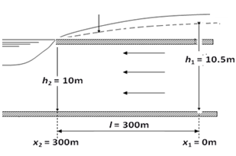
(6) Use Darcy's Law to calculate the groundwater flow per unit length of channel from the aquifer to the stream shown in Figure. Assume the aquifer is homogeneous and isotropic with K = 3 m d^{-l}. Also, determine the transmissibility coefficient for the aquifer.
Impervious layer
Impervious layer
Piezometric surface

(7) For the homogenous aquifer shown in the following figure, it is required to:
- using the basic principles of both Darcy law and continuity equation, deduce one-dimensional flow equation and an expression for seepage per unit width from channel (A) to Channel (B).
- If K = 30 m/day, B = 100 m, and h₁ = 5m, calculate the value of seepage per unit width.
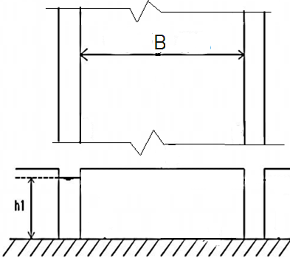
- Compute the time required to the flow reach at channel (B).
X
X
Sec X-X
Dry channel
(B)
Channel
(A)
h

(8) A tube well is constructed in a confined aquifer, drawdown of 3 m when the diameter of the well is 20 cm and the thickness of the aquifer is 30 m. assume the coefficient of hydraulic conductivity to be 35 m/day. Radius of influence is 300 m. it is required to:
- Deduce an expression for the discharge from this well if the well is fully penetrating the aquifer.
- Compute the value of transmissibility for the aquifer.
- Compute the value of well discharge in liter per hours.
P.T.O
- If the diameter of the well is doubled, find the percentage increase in the discharge; assume the other conditions remaining the same.
- Comment in your results.

SHEET (3)
(1) What are the principle objectives of a properly designed well?
(2) State an expression used for computed minimum length of the well screen.
(3) What are the conditions that the optimum screen length depend on?
(4) Calculate the minimum length of well screen using the following data: the hydraulic conductivity of the aquifer is 25 m/d, the screen entrance velocity should then not exceed 0.015 m/sec, the well screen with an open area of 20% and a diameter of 0.25 m, and capacity is 200m³/h.
(5) What are the formations that the application of a gravel pack is recommended?
(6) What are the used criteria in a stable gravel-pack gradation?
(7) Explain briefly, the well design.
(8) What are the optimizing options with wells for irrigation and drainage purposes?
(9) Write short notes about, the well construction and maintenance.
(10) Write short notes about well casing.

SHEET (4)

(1) Explain briefly the phenomena of "saltwater intrusion".
(2) Derive an expression for the GHYBEN-HERZBERG equation.
(3) What are the used techniques for controlling saltwater intrusion?
(4) Write short notes with neat sketches about "Reduction of Pumping Rates".
(5) Write short notes with neat sketches about "Relocation of Pumping Wells".
(6) Write short notes with neat sketches about "Subsurface Barriers".
(7) Write short notes with neat sketches about "Natural Recharge".
(8) Write short notes with neat sketches about "Artificial Recharge".
(9) Write short notes with neat sketches about "Abstraction of Saline Water".
(10) Write short notes with neat sketches about "Combination Techniques".
(11) Write short notes with neat sketches about "Controlling of Saltwater Intrusion Using (ADR)".
(12) For the shown aquifer in the following figure, K = 50 m/day, d = 20 m, ρ_{s} = 1025 kg/m³, and ρ_{f} = 1000 kg/m³. It is required to:
- Determine the type of the aquifer.
- Classify the shown aquifer according to Homogeneity and Isotropy.
- Using Darcy law, compute the full discharge (Q) in m³/day and uniform recharge (q_{u}) in m³/day/m.
- Calculate the coefficient of transmissibility for the aquifer.
- Define the saltwater intrusion.
- Compute the intrusion length due to uniform recharge (q_{u}) only.
- For the shown raw of wells, if radius of circle of influence (R) equals 500 m, compute the required number of wells.
- Compute the maximum intrusion length due to both the uniform recharge and the raw of wells, if each well pumping 600 m³/day.
- Calculate the maximum rate of pumping from for each well, if number of wells equals 5.
y
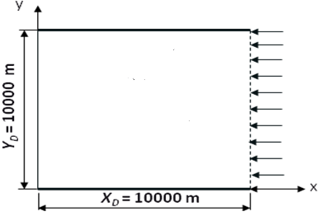
q_{u}
A
Plan
6000 m
Raw of wells

A

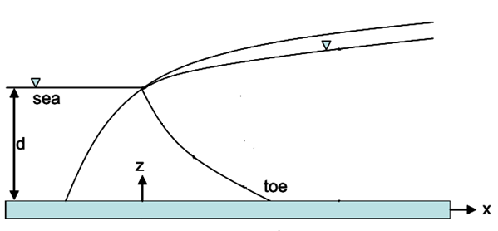
Sec A-A
25 m
24 m
1000 m
q_{u}
Impervious layer

