Hydrology and irrigation engineering

**Sheet (1)**

1- Define the following hydrologic terms:

- Drainage basin - Drainage divide

- Concentration point - Concentration time

2 - Correct the following sentences:

* Streams and rivers are fed only by both overland flow and ground water flow.
* Runoff coefficient can be defined as the ratio between infiltration rate and precipitation.

3 - Explain the hydrologic cycle and Write its major elements.

4 - Discuss in your own words the importance of studying hydrology.

5 - In a given year, a lake with an area of 2500 square Km received 3250 Mm3 of precipitation. The average rate of outflow from the lake was 30 m3/s. The lake storages are estimated equal 5*104 Mm3 and 5.025*104 Mm3 for t = 0 and t = 1 year respectively. Estimate the amount of water losses in centimeters.

6 - A small catchment of area 150 ha received a rainfall of 7.0 cm/hr in 90 min duration due to a storm. At the outlet of the catchment, the stream draining the catchment has an initially discharge equal to 1.0 m3/sec before the storm. After the beginning of the storm, the stream discharge is increased to 3.0 m3/sec.

**Sheet (2)**

1. Correct the following sentences:

* Precipitation is classified according its form to Convective, Orographic, and Cyclonic.
* Symon’s rain gauge is considered the famous type of automatic rainfall gauges.
* Presentation of rainfall data is carried out using either double mass curve or hydrograph.
* Adjustment of rainfall records can be performed using accumulated mass curve.

1. Explain briefly the types of precipitation.
2. Explain briefly two types of recording rainfall gauges.
3. The following table listed rainfall records for gauge station **X** and the surrounding 9 gauge stations in mm. Check the consistency of the record at gauge station **X** using the method of Double Mass Curve**.** If a change in regime has occurred, determine the year at which the regime is changed and correct the data to be in the same regime.

|  |  |  |  |  |  |  |  |  |  |  |
| --- | --- | --- | --- | --- | --- | --- | --- | --- | --- | --- |
| **Gauge**  **Year** | X | 1 | 2 | 3 | 4 | 5 | 6 | 7 | 8 | 9 |
| 2001 | 35 | 30 | 27 | 27 | 25 | 30 | 29 | 30 | 26 | 28 |
| 2002 | 35 | 29 | 28 | 29 | 23 | 29 | 30 | 32 | 24 | 28 |
| 2003 | 40 | 30 | 34 | 33 | 31 | 35 | 29 | 31 | 33 | 32 |
| 2004 | 30 | 25 | 23 | 26 | 22 | 27 | 21 | 24 | 24 | 24 |
| 2005 | 35 | 28 | 29 | 29 | 30 | 32 | 23 | 24 | 29 | 28 |
| 2006 | 25 | 19 | 21 | 21 | 19 | 22 | 18 | 17 | 23 | 20 |
| 2007 | 25 | 21 | 19 | 19 | 21 | 18 | 22 | 23 | 17 | 20 |
| 2008 | 25 | 19 | 19 | 21 | 21 | 22 | 23 | 17 | 18 | 20 |
| 2009 | 30 | 23 | 25 | 22 | 26 | 21 | 27 | 23 | 25 | 24 |

1. The precipitation gauge X is stopping of operation for one month. In this month, the measured precipitation depths at its adjacent stations A, B, and C are 22, 25, and 29 mm respectively. Estimate the missing precipitation data at station X in this month. Knowing that, the annual precipitations at X, A, B, and C are listed in the following table. (All data in mm)

|  |  |  |  |  |  |  |  |  |  |
| --- | --- | --- | --- | --- | --- | --- | --- | --- | --- |
| Year | **2001** | **2002** | **2003** | **2004** | **2005** | **2006** | **2007** | **2008** | **2009** |
| station |
| **X** | 340 | 350 | 400 | 300 | 350 | 250 | 250 | 250 | 300 |
| **A** | 300 | 290 | 300 | 250 | 280 | 190 | 210 | 263 | 230 |
| **B** | 270 | 280 | 340 | 230 | 290 | 210 | 190 | 280 | 250 |
| **C** | 270 | 290 | 330 | 260 | 290 | 210 | 217 | 226 | 220 |

**Sheet (3)**

1. Explain briefly the Mass Transfer Method.
2. Correct the following sentences:

* The most accurate method for determining evaporation rate is the water budget method.
* Double ring infiltrometer is used for measuring evaporation rate in field.
* The interception loss is the major part in the hydrologic losses.
* The infiltration rate in wet soil is greater than the corresponding one in dry soil.

1. Complete the following sentences using suitable *English expressions*:

* The most accurate method for determining evaporation rate is ……………………..
* Evaporation pan data must be adjusted because ………..……& …..………
* Empirical formulas used for measuring evapotranspiration are ………....& ……..….& ………..…
* The ………………….. loss is the minor part in the hydrologic losses.
* The purpose of the outer tube in the double ring infiltrometer is ……………………….

1. A watershed covering 600 acres (1 acre = 4047 m2) had a storm in which rain fell at a rate of 0.7 in/hr for the first two hours, 0.5 in/hr for the next five hours, and 0.6 in/hr for the following one hour. Determine: (a) the total volume of infiltration over 8-hr period when the initial infiltration capacity equals 0.5 in/hr, the equilibrium capacity equals 0.1 in/hr, and take time constant equals 0.8 hr-1, and (b) if the losses due to evapotranspiration is estimated equal to 1.0 in, determine the depth of an artificial reservoir used for storing the excess rainfall. The cross sectional area of an artificial reservoir is taken equal to 104 m2.
2. For a given week from August month, a watershed had a storm in which both rainfall data and the infiltration rate are presented in the shown Figure. Determine:

* The total volume of rainfall in centimeters.
* The total volume of infiltration over 10-hr period when the time constant equals 0.8 hr-1.
* If the watershed under study is planted with alfalfa plants, determine the value of water consumption through this week, using Blaney-Criddle formula, according to the following data. Average temperature through this week = 22.3o C, P for August month = 10.68 %, and average Blaney coefficient through the week = 1.08.
* If the rainfall excess is 0.53 m3/s, calculate the area of the watershed in acres.

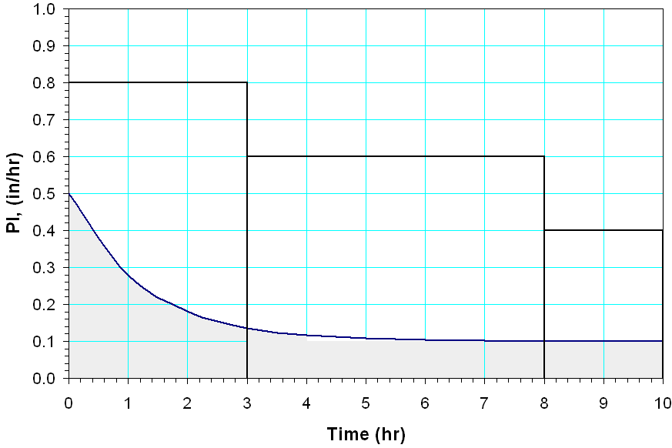

Hyetograph corresponding to question (4)

1. For a given week from September month, a watershed covering 600 acres had a storm in which rainfall data is presented in the shown figure.



1. Draw the corresponding hyetograph (take used units: ***in/hr*** for precipitation intensity and ***hr*** for time and time interval is 0.5 hours).
2. Determine the volume of the rain that fell during the storm in ***acre-feet***.
3. If the watershed under study is planted with alfalfa plants, determine, using Thornthwaite formula, the potential evapotranspiration through this week according to the following data. The percentage of monthly daylight hours to 360 hours is 1.15, average temperature through this week is 22.3o C, annual heat index is 60.0, and coefficient (a) is taken equal to 1.211.
4. Compute the value of *ф* – index for the storm if the runoff coefficient is 0.6.

**sheet (4)**



1. Complete the following sentences using suitable *English expressions*:

* Concentration point is defined as …………………………
* Area under the hydrograph curve consists of …....and ……
* 3 – hr UH means ……………………………….
* Duration change of unit hydrograph is carried out using.….

1. The following table listed the values of a **2-hr Unit Hydrograph**.

|  |  |  |  |  |  |  |  |  |  |  |  |
| --- | --- | --- | --- | --- | --- | --- | --- | --- | --- | --- | --- |
| T, hr | 0 | 1 | 2 | 3 | 4 | 5 | 6 | 7 | 8 | 9 | 10 |
| 2-hr UH (cfs) | 0 | 75 | 250 | 300 | 275 | 200 | 100 | 75 | 50 | 25 | 0 |

(i) Convert the tabulated **2-hr UH** to a **3-hr UH** using the S-curve method.

(ii) Using the results of the previous step to calculate the ordinates of a flood hydrograph resulting from **3-hr** uniform excess rainfall of intensity 0.83 in/hr and the base flow was 100 cfs (constant).

(iii) Use the obtained value of peak flow, resulting from aforementioned step, to design a collecting drain having trapezoidal cross section using Chezy equation if b = 2y, z = C = 50, and S = 0.0001.

1. The shown figure is a plan view of a watershed of area equal to 40000 m2. The area topography induces the flow pattern shown by arrows. Inlet I collect surface runoff from this area. The relationship between mean rainfall intensity and duration for a given recurrence can be represented as , where *a* and *b* are constants have values equal 3 cm and 0.17 hr respectively and the time of concentration (*tc*) equals 10 minutes. Use both rational method and Chezy equation to design a rectangular cross section of inlet I according the following data: runoff coefficient = 0.7, Chezy coefficient = 50, longitudinal slop of inlet I = 0.0001, and bottom width of cross section is twice water depth.

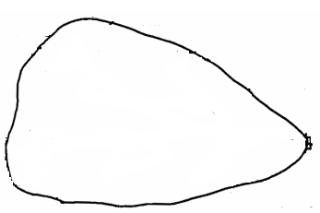

Inlet I

**شيت (1)**

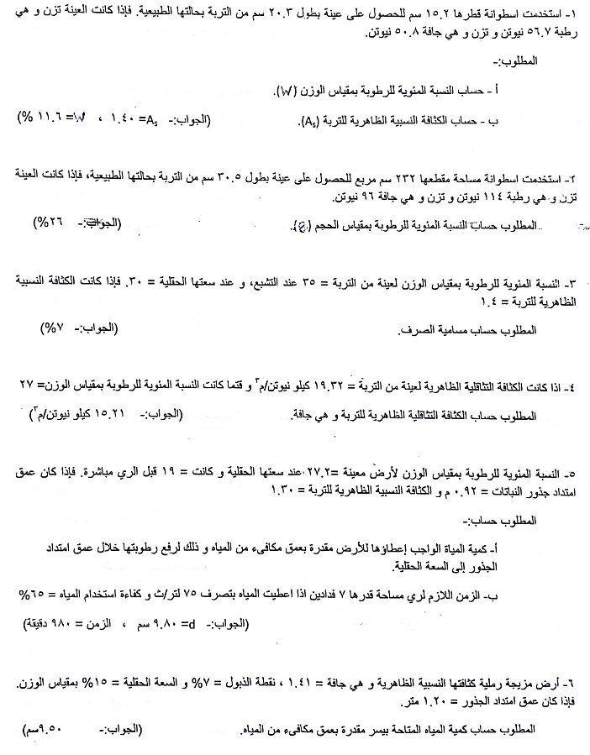

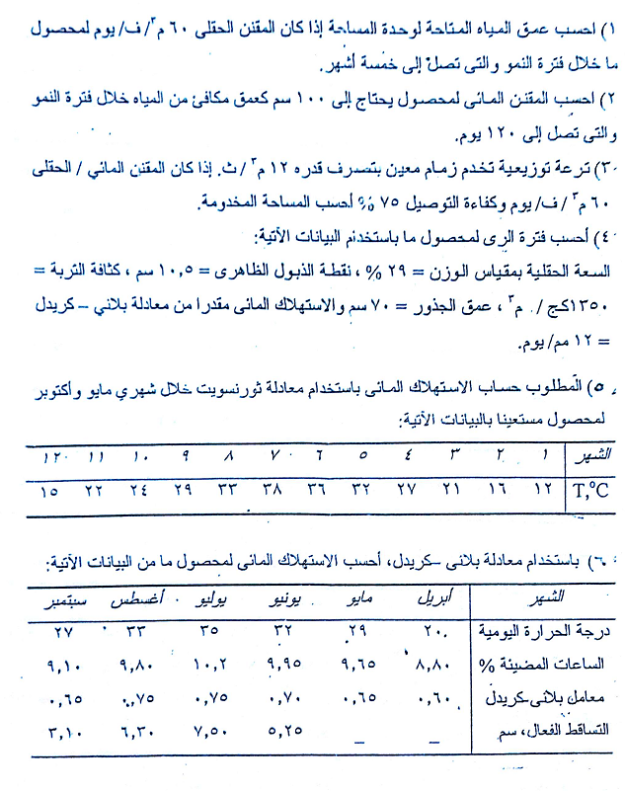

**شيت (2)**

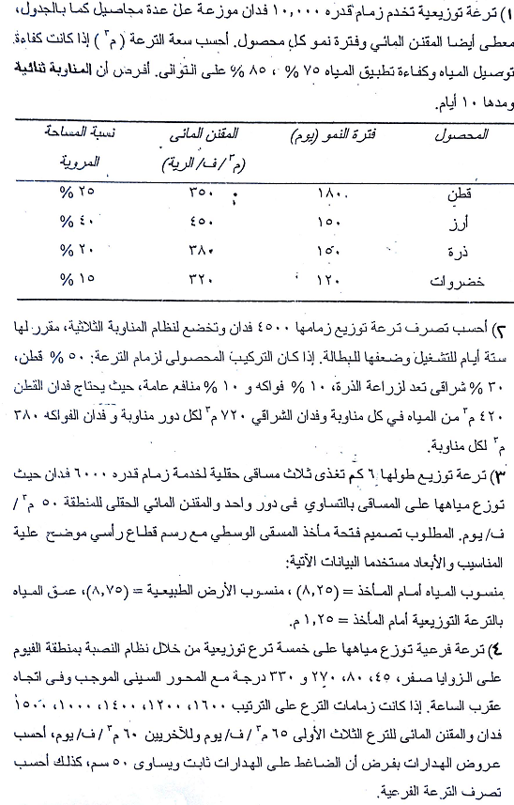

**شيت (3)**

